Enzymes

What Are Enzymes?
Substances that speed up chemical reactions are called catalysts. Organic catalysts are called enzymes.
Enzymes are specific for one particular reaction or group of related reactions.
Many reactions cannot occur without the correct enzyme present.
They are often named by adding "ase" to the name of the substrate. Example: Dehydrogenases are enzymes that remove hydrogen.

Induced-Fit Theory
active site binds with the substrate like a key fitting a lock
shape of the enzyme must match the shape of the substrate
very specific;
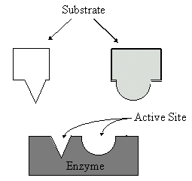
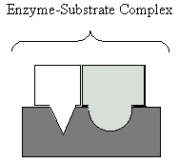
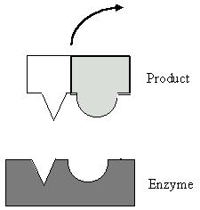
often does not fit exactly in the active site
induces a change in the enzymes conformation (shape) to make a closer fit
does not form a chemical bond with the substrate
released and the enzyme returns to its normal shape
remains unchanged
can be reused

Activation Energy and Enzymes
activation energy is considerably less when enzyme is present
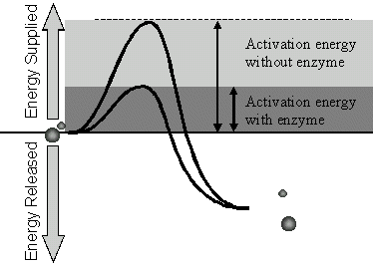

Conditions that Affect Enzymatic Reactions

Rate of Reaction
up to 10 billion times faster than those without
some enzymes catalyze up to 500,000 molecules per second

Substrate Concentration
At lower concentrations, the active sites on most of the enzyme molecules are not filled because there is not much substrate. Higher concentrations cause more collisions between the molecules. With more molecules and collisions, enzymes are more likely to encounter molecules of reactant.
The maximum velocity of a reaction is reached when the active sites are almost continuously filled. Increased substrate concentration after this point will not increase the rate. Reaction rate therefore increases as substrate concentration is increased but it levels off.
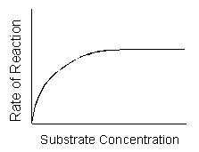

Enzyme Concentration
If there is insufficient enzyme present, the reaction will not proceed as fast as it otherwise would because there is not enough enzyme for all of the reactant molecules.
As the amount of enzyme is increased, the rate of reaction increases. If there are more enzyme molecules than are needed, adding additional enzyme will not increase the rate. Reaction rate therefore increases as enzyme concentration increases but then it levels off.
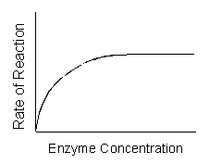

Temperature
Higher temperature generally causes more collisions among the molecules and therefore increases the rate of a reaction. More collisions increase the likelihood that substrate will collide with the active site of the enzyme, thus increasing the rate of an enzyme-catalyzed reaction.
Above a certain temperature, activity begins to decline because the enzyme begins to denature.
The rate of chemical reactions therefore increases with temperature but then decreases.
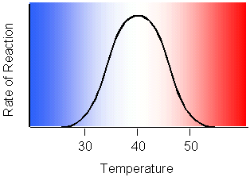

pH
Each enzyme has an optimal pH.
A change in pH can alter the ionization of the R groups of the amino acids. When the charges on the amino acids change, hydrogen bonding within the protein molecule change and the molecule changes shape. The new shape may not be effective.
The diagram below shows that pepsin functions best in an acid environment. This makes sense because pepsin is an enzyme that is normally found in the stomach where the pH is low due to the presence of hydrochloric acid. Trypsin is found in the duodenum, and therefore, its optimum pH is in the neutral range to match the pH of the duodenum.
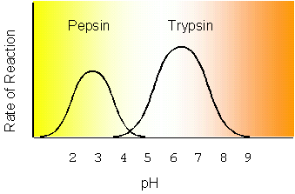

Metabolic Pathways
Metabolism refers to the chemical reactions that occur within cells. A hypothetical metabolic pathway is shown below.
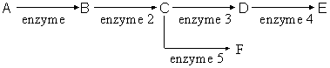
Reactions occur in a sequence and a specific enzyme catalyzes each step.
Intermediates can be used as starting points for other pathways. For example, "C" in the diagram above can be used to produce "D" but can also be used to produce "F".

Cyclic Pathways
Some metabolic pathways are cyclic. The function of the cyclic pathway below is to produce E from A. Several intermediate steps are involved in the production of E.
First, "A" combines with "F" to produce "B". "B" is then converted to "C", which is then converted to "D". "D" is then split to produce "E" (the desired product) and "F". "F" can be reused by combining with more "A".
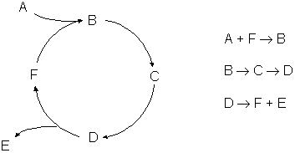

Regulation of Enzyme Activity
Cells have built-in control mechanisms to regulate enzyme concentration and activity.
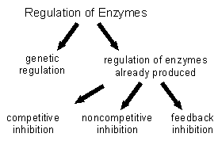

Regulation of Protein Synthesis (Genetic Regulation)
Enzymes are proteins. You can regulate them by making more or less of them as needed. The topic of regulating protein synthesis is deferred to a later chapter.

Regulation of Enzymes Already Produced

Competitive Inhibition
In competitive inhibition, a similar-shaped molecule competes with the substrate for active sites.


Noncompetitive Inhibition
Another form of inhibition involves an inhibitor that binds to an allosteric site of an enzyme. An allosteric site is a different location than the active site.
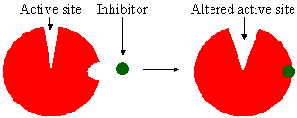
The binding of an inhibitor to the allosteric site alters the shape of the enzyme, resulting in a distorted active site that does not function properly.
The binding of an inhibitor to an allosteric site is usually temporary. Poisons are inhibitors that bind irreversibly. For example, penicillin inhibits an enzyme needed by bacteria to build the cell wall.

Feedback Inhibition
Negative feedback inhibition is like a thermostat. When it is cold, the thermostat turns on a heater which produces heat. Heat causes the thermostat to turn off the heater. Heat has a negative effect on the thermostat; it feeds back to an earlier stage in the control sequence as diagrammed below.
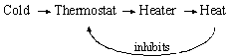
Many enzymatic pathways are regulated by feedback inhibition. As an enzyme's product accumulates, it turns off the enzyme just as heat causes a thermostat to turn off the production of heat. The end product of the pathway binds to an allosteric site on the first enzyme in the pathway and shuts down the entire sequence.
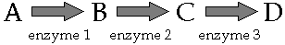

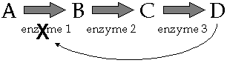

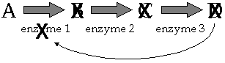

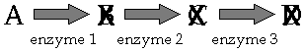

Feedback inhibition occurs in most cells.

